TVTA Fall Conference
September 28-29, 2019

Math for Breakfast! Calculations, Dilutions and % Solutions
Jessica Birdwell, B.A., LVMT, VTS (Anesthesia)

At some point in every veterinary professional’s career they have encountered a crisis as a result of improper calculations where a patient has received an erroneous amount of something. Research documents these errors are primarily a result of a human error during the calculation process. Remember, even the most beneficial can be ineffective or dangerous if the administered dose has been calculated incorrectly. Whether food, fluids, or diagnostic/therapeutic agents these products can become the turning point of the patient’s treatment. It remains vital that every veterinary health care team member firmly ingrains the basics of dose and dosage calculations into their working memory. This lecture will focus on reviewing basic medical mathematics and dosage calculations techniques that veterinary member could encounter on a daily basis.

Common drug errors
Wrong medicine | Omission of administration | Incorrect dose calculation
Wrong route | Wrong patient | Inadequately trained staff
Wrong concentration | Wrong labeling | Inappropriate abbreviations
Wrong fluid | Wrong dispensing | Excessive workload
Wrong rate | Ambiguous labels/packaging | Distractions
Wrong time | Similar drug name/packaging | Unavailable medications
Unauthorized administration | Illegible handwriting | Poor performance

Top Ten Tips for Reducing Errors
- Quiet location dedicated for checking/preparing drugs to prevent distractions.

- Know the drug or know where to find out about the drug – actions, interactions, side effects, contraindications, methods of dilution, displacement values and compatibilities.

- Check the patient identification – weight, condition, allergies and other current medications.

- Avoid decimal points during record keeping to minimize risk of tenfold error. If a decimal point is unavoidable remember to use a leading zero if the amount is less than 1 milliliter. Do not use trailing zeros, e.g. 1.0, this can easily lead to a tenfold error.

- Always include the units of measure when doing calculations. Monitoring the cancellation of units is the best means of self-checking.

- Non-standardized abbreviations are easily misinterpreted so do not use them.

- Ensure prescriptions are written correctly – clearly, in print, with units of measurement written out in full, with current patient weight, signed and dated.

- Always refer to the local Trust drug information sources if you have questions. If still in doubt seek help from other members of the multidisciplinary team or the pharmacy helpline.

- Comply with local Trust policies and guidelines.

- Adhere to preparation and administration instructions – correct diluent, correct pH, correct time over which drug should be given, preparation recommendations, how the drug should be stored.

Terminology
Unit - a dimension that is given to a number.
Units of Measurement: Weight, Volume, Length
- Weight and volume are not the same thing. They are given different units.
- The volume is the amount of space an object takes up.
- The weight is how much that volume weighs.
Dosage: The units per weight to be given (ie mg/kg, mcg/kg)
Dose: The total units per treatment. Should be expressed in weight not volume.
Frequency: How often the drug is administered.
Duration: For how long of a period of time the drug will be administered.

Systems of Measurement
The English system: Historical unit of measurement used in England until 1824. It evolved from a combination of
Anglo-Saxon and Roman units of measurement. Used in the United States and several other countries

The metric system: The most commonly used system of measurement around the world. It is used almost exclusively in the medical professions. It is a system that builds from the decimal system and utilizes the powers of 10.

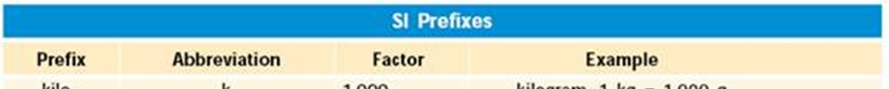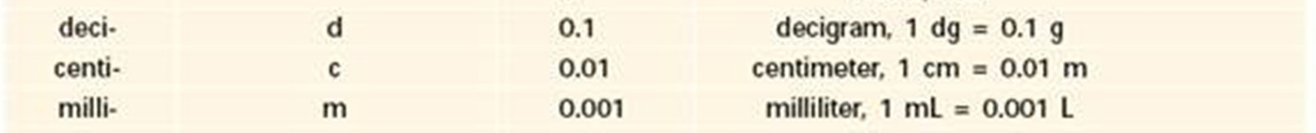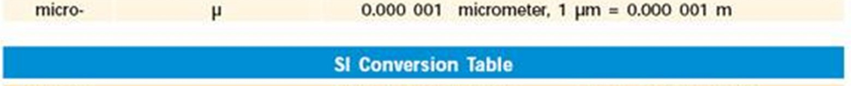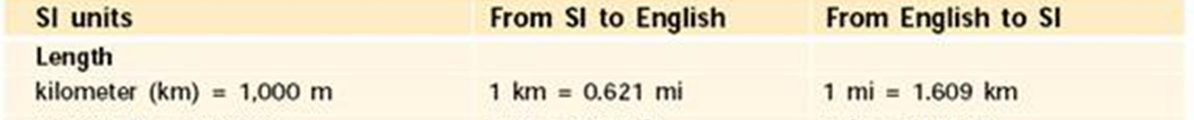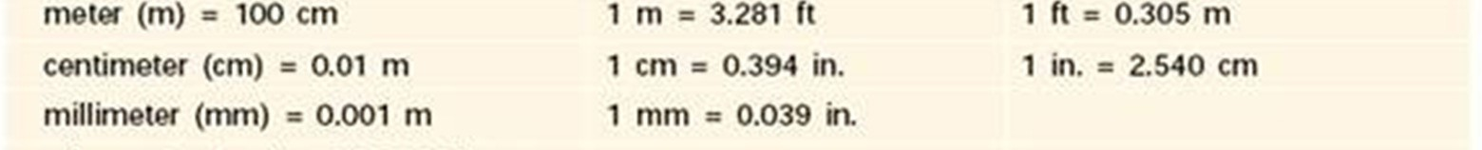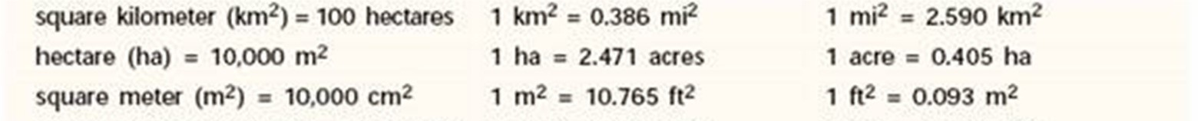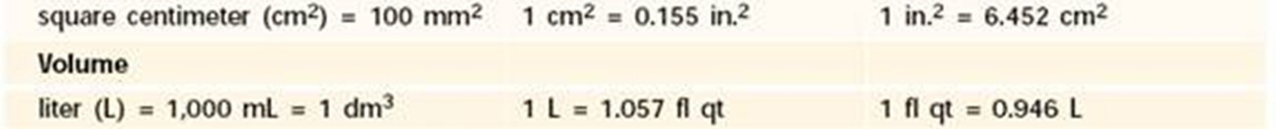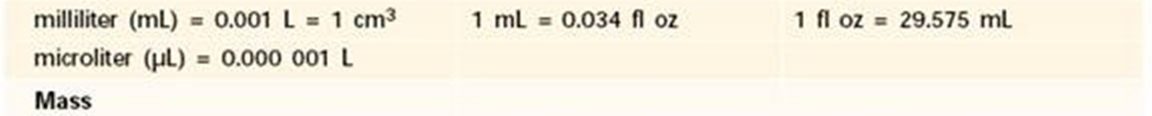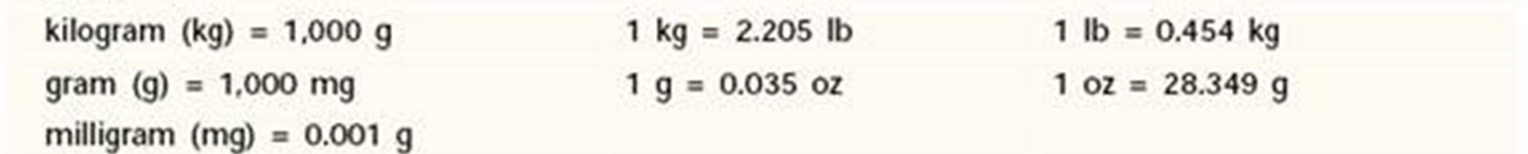
http://www.austincc.edu/rfofi/metricscience/MetricSysPage_clip_image002.png

1) Decimal review: The place values to the right of the decimal point all end in “th.” Going to the right is tenths, hundredths, thousandths, ten-thousandths, etc.

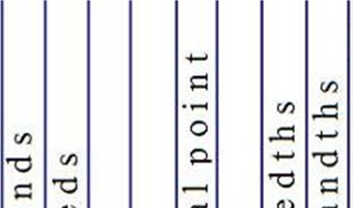
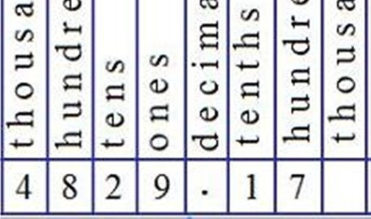
http://3.bp.blogspot.com/-MFtWIYFqyw0/UKf3GDxQWYI/AAAAAAAAAA0/KHnUGKwz6VY/s320/decimal_place_value_chart_1.jpg

It is important to recognize that there are limitations to the volume of a substance that you can administer due to the graduated accuracy of the delivery method. Just because you calculate to a specific place setting doesn’t mean you can administer that amount accurately.

Example 1: Calculated amount = 5.55ml. 6ml syringes are graduated only to the tenths place you cannot draw up 5.55ml. You would need to draw up 5.6ml.

Example 2: Calculated amount = 0.75ml. 1ml syringes are graduated to the hundredths place so you can draw up
0.75ml with accuracy.

- Converting fractions to whole number: Fractions can be converted into a whole number (with or without decimals) by dividing the numerator (top #) by the denominator (bottom #)

Example: ¼ = 0.25

- Converting percentages to decimals: Percentages refer to parts per 100. For example, 3% is equal to 3 parts out of 100. It can be written as a fraction which in turn can be converted into a decimal or whole number by dividing by 100.

Example: 3% = 3 parts out of 100 = 3 = 0.03
100

- Ratios and Proportions: Ratios and proportions are fractions written in a different format.

Ratio - the first number is the numerator, and the second number is the denominator. Instead of using a line with the numerator on the top and the denominator on the bottom, the numerator and the denominator are separated by a colon (:).
Example: 1 : 2 = 1 part per 2 parts

This can then be turned into a fraction by dividing 1 by 2 = ½

Next the fraction can be changed into a whole number by dividing 1 by 2 = 0.5

Finally it can be turned into a percentage by multiplying by 100 or essentially moving the decimal point two places to the right 0.5= 50%.
4) Ratios and Proportions: Ratios and proportions are fractions written in a different format.

Proportions – relationship between two ratios

Example: 1 tablet:200mg = 2 tablets:400mg or 1 tablet = 2 tablets
200 mg 400 mg

5) Solving for X using proportions: If one side of the equation must equal the other side, we can use this relationship to find a missing value.

Example 1: 1 tablet = 2 tablets
200 mg 400 mg

If we didn’t know how many tablets would be required to prescribed 400 mg we could place an x in that space and solve for x using cross-multiplication.

Example 2: 1 tablet = x tablets then cross-multiply 400mg(1tablet) = x then do the math! x = 2
200 mg 400 mg 200mg
6) Dimensional Analysis: A mathematical process of manipulating units to solve equations. The goal of this approach to drug calculation problem solving is to cancel out unwanted units leaving only those units you want answered or expressed. This method of mathematic problem solving is used in chemistry with great success and heavily utilized in other professional fields.

Dimensional Analysis utilizes known conversion factors to permit for elimination of units. Before you start a calculation, identify the conversion factors that will be needed to reach the intended unit goal.

Example 1: Covert 50 lb to kg
Conversion Factor needed: 1kg = 2.2lb

- Start with what you were given in the equation = 50 lb.

- We need to end up with kg in our answer so we know that we will need to cancel out the unit of lbs.

- We know that cancellation requires the unit we want to cancel to be in the numerator in one conversion factor and in the denominator of the other.

50 lb X 1 kg = 22.7 kg (lbs cancel one another out and we are left with the units we want)
2.2 lb

Example 2: Do the equation the opposite direction! Convert 22.7 kg to lbs. Conversion Factor needed: 1kg = 2.2 lbs

- Start with what you were given in the equation = 22.7kg

- We need to end up with lbs in our answer so we know that we will need to cancel out the unit of kg.

- The conversion factor looks different from the previous equation but the units are just flipped!

22.7kg X 2.2lb = 50 lbs
1 kg

Drug Calculations
Regardless of which method you use to calculate your medications the most essential factor is that you FIND A ROUTINE!!!! Always stick with the same process when calculating starting with patient weight and ending with the desired amount or rate with the appropriate units.

Some basic questions to ask yourself:
  - What do I know?
  - What do I need to solve for?
  - Do I need to convert?
  - How do I set up my problem to solve?
  - DOES MY ANSWER MAKE SENSE?

NOTES:
- Figure out the conversation factors you will need before you start to MEMORIZE THE MOST COMMON CONVERSION FACTORS!!!
- Begin by ALWAYS writing it down until you have mastered the process
- Always triple check yourself – seek another veterinary professional for cross reference
- ALWAYS write the units o Until you are comfortable DO NOT skip steps by calculating things in your head to Keep numbers in the calculator to avoid rounding errors
- ALWAYS place zeros in front of decimal points to reduce errors IE 0.8mg instead of .8mg
- The use of fractional doses is unsafe and should be avoided IE 0.1g should be written as 100mg or
0.5mg should be written as 500 microgram. The unnecessary use of decimal points should be avoided IE 3mg not 3.0mg.

1) Dose
SAMPLE 1: Dosage in mg/kg
Needed: mg of Diazepam Weight: 22lbs Dosage: 0.5mg/kg

Conversion Factors Needed: ____________________________________________ Final Units Needed: _______

Answer: _________________

SAMPLE 2: Dosage in mcg/kg
Needed: mg of Fentanyl Weight: 10 kg Dosage: 5 mcg/kg

Conversion Factors Needed: ____________________________________________ Final Units Needed: _______

Answer_________________

2) Volumes (Requires knowledge of drug concentration)

SAMPLE 1: Dosage mg/kg to mls
Needed: mls of Diazepam Weight: 22 lbs Dosage: 0.5mg/kg

Conversion Factors Needed: ____________________________________________ Final Units Needed: _______

Answer:_________________
SAMPLE 2: Dosage mcg/kg to mls
Needed: mls of Fentanyl Weight: 20 kg Dosage: 5 mcg/kg

Conversion Factors Needed: ____________________________________________ Final Units Needed: _______

Answer: _________________
SAMPLE 3: Fluid rate in drops/sec
Needed: drops/sec of NaCl Weight: 44 lbs Fluid rate: 5 ml/kg/hr

Must know what size primary fluid set you will be using. Primary infusion set size: Macrodrip @ 15 drops/sec

Conversion Factors Needed: ____________________________________________ Final Units Needed: _______

Answer: _________________

3) Constant Rate Infusions – Some medications must be continuously delivered over the course of treatment for a variety of reasons. Most commonly it is because a specific medication is rapidly metabolized by the body, and in order for it to be effective it must be continuously administered.

Though there are many steps in the calculation process, remember to always start the process in the same manner as you would if you were doing a simpler calculation.

SAMPLE 1: using mcg/kg/hr to ml/hr

Needed: ml/hr of Dexmedetomidine Weight: 10kg CRI Rate: 2mcg/kg/hr

Conversion Factors Needed: ____________________________________________ Final Units Needed: _______

Answer: ____________________
SAMPLE 2: using mcg/kg/min to ml/hr

Needed: ml/hr of Ketamine Weight: 88lbs CRI Rate: 10 mcg/kg/min

Conversion Factors Needed: ____________________________________________ Final Units Needed: _______

Answer: ____________________

4) Dilutions: Dilutions are weakened solutions. Dilutions allow for administration of larger volumes at a lower concentration versus smaller volumes at the higher concentration.

It is simply how many parts of the product you are diluting in the total number of parts of the expected final solution. Remember dilutions are as simple as taking a specific mg amount of a drug and adding mls of diluent
(usually saline). - AKA diluting out the concentration of drug you already have to a different (lower) concentration.

All you need to know is the total mgs of the drug in its current concentration and total number of mls you want to have in your final product.

Example 1: Stock concentration is 10mg/ml. Want it diluted to 1mg/ml. How much of the stock solution do we need to dilute in a total of 5 mls?

Formula = C₁V₁ = C₂V₂ C₁ = 10mg/ml V₁ is unknown C₂ = 1mg/ml V₂ = 5ml Total volume in syringe

Solve for the unknown . V₁ = C₂V₂ V₁ = 1mg/ml(5ml) V₁ = 0.5 ml
C1 10mg/ml

You will add 0.5 ml of the original concentration (10mg/ml) to 4.5 ml of saline to have a dilution of 1mg/ml in a total of 5ml. (5ml total – 0.5 ml drug = 4.5 saline to make a 0.5 in 5 dilution.)

OR if you prefer to not use a formula and simply use conversion factors and dimensional analysis:

5ml (Total volume of solution) x 1mg (Desired Concentration) = 5mg (number of mg of stock solution needed) ml

5mg x ml = 0.5ml of drug at original concentration to added to 4.5 mls of saline for a total of 5 mls.
10mg

SAMPLE 1: DILUTE Dexmedetomidine to a concentration of 0.005 mg/ml in 10ml. Determine how many mls of the original concentration and how many mls of saline you will need for the dilution.

***USE WHICHEVER METHOD YOU ARE MOST COMFORTABLE WITH***

Needed: ml of Dexmedetomidine to make .005mg/ml Total Volume: 10ml

Conversion Factors Needed: ____________________________________________ Final Units Needed: _______

Answers: _____________ ______________

SAMPLE 2: DILUTE Ketamine to a concentration of 1 mg/ml in 10 ml. Determine how many mls of the original concentration you will need and how many mls of saline you will need for the dilution.

Needed: ml of Ketamine to make 1 mg/ml Total Volume in syringe: 10ml

Conversion Factors Needed: ____________________________________________ Final Units Needed: _______

Answers: _____________ ______________

Now substitute the NEW concentrations into the constant rate infusions we did before:

SAMPLE 1: using mcg/kg/hr to ml/hr
Needed: ml/hr of Dexmedetomidine Weight: 10kg CRI Rate: 2mcg/kg/hr

****USE DILUTED CONCENTRATION****

Conversion Factors Needed: ____________________________________________ Final Units Needed: _______

Answer: ____________________

SAMPLE 2: using mcg/kg/min to ml/hr
Needed: ml/hr of Ketamine Weight: 88lbs CRI Rate: 10 mcg/kg/min

****USE DILUTED CONCENTRATION****

Conversion Factors Needed: ____________________________________________ Final Units Needed: _______

Answer: ____________________

5) % Solutions: In clinical practice we create solutions when we reconstitute powdered medications with a diluent. We also use pre-manufactured medications or fluids that are mixed in solution and reported as a %. We can also create solutions using a drug and diluent.

Example 1: Dextrose bottles are listed as a 50% dilution.

50% = 50 dextrose parts out of a total of 100. (For every ml of solution it is half dextrose and half diluent)

% can be converted to mg/ml by moving the decimal place over ONE SPACE TO THE RIGHT (MULTIPLY BY 10)

50% X 10 = 500 mg/ml is the concentration of the drug.

SAMPLE 1: What is the concentration in mg/ml of 2% Lidocaine?

Answer:________________

6) Combinations of Methods: Realistically, every calculation we do in clinical practice is a combination of multiple methods.

SAMPLE 1: Create a 5% dextrose solution diluted in a total of 1000ml NEEDED: mls of dextrose and ml of saline

Conversion Factors Needed: ____________________________________________ Final Units Needed: _______

Answer:________________

Conclusion:
Studies have proven that repetition is a key factor in education and memorization. In terms of medical mathematics and/or dosage calculations repetition is essential in making it second nature in a crisis situation. For veterinary professionals it is important that they master routine dosage calculations on a regular basis to ensure the greatest accuracy. All veterinary professionals are obligated to define their own limits and comfort with medical mathematics and strengthen their skills thru continued education. This lecture offered an opportunity for veterinary technicians to review and practice medical mathematics as well as dosage calculations. It is important to maintain continued improvement thru occasional self-practice tests or exams to identify problem areas before a crisis situation occurs. Below are some references for the laboratory material and additional resources for self-examination.

References:
- Medical Mathematics. 2014. Rivercity Veterinary Conference. Proceedings by Melissa Allett and Jessica Birdwell.
- Medical Mathematics and Dosage Calculations for Veterinary Professionals. 2009. 2nd edition by Robert Bill published by John Wiley & Sons, Inc.
- http://highered.mcgraw-hill.com/sites/dl/free/0073374172/636324/SampleChapter.pdf Methods of Dosage calculations. Chapter 7 McGraw-Hill
- Applied Pharmacology for Veterinary Technicians. 2009. 4th edition by Boyce P. Wanamaker, Kathy Lockett Massey. Published by Elsevier, Inc.
- Essential Calculations for Veterinary Nurses and Technicians. 2009. 2nd edition. By Terry Lake and Nicola Green published by Elsevier Limited.

Additional Calculation Requests:

